VAL 6 INDUSTRIAL INFRA RED HEATER FIR1300-E

HRP1001

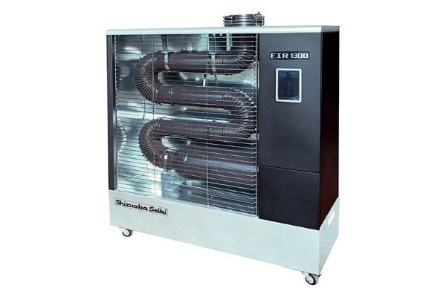

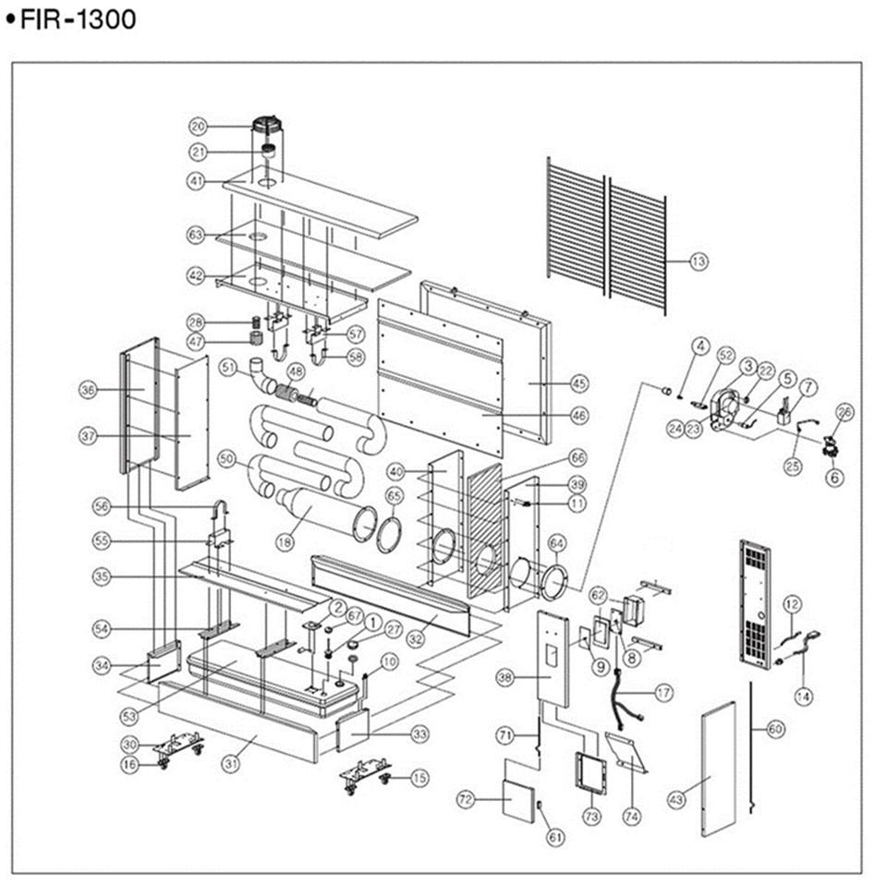

|  |  |  |  |
| --- | --- | --- | --- |
| **Position** | **Quantity** | **Description** | **Part Number** |
| 1 | 1 | Filter | TKH080-001 |
| 2 | 1 | Filter only | TKH080-SS1 |
| 3 | 1 | Fuel Gauge | TKH080-002 |
| 4 | 1 | Burner | TKH121-003 |
| 5 | 1 | Nozzle | TKH121-004(0.4G) |
| 7 | 1 | Photocell | TKH080-005 |
| 8 | 1 | Pump | TKH121-006 |
| 9 | 1 | Ignitor | TKH080-007 |
| 10 | 1 | P.C.B | TKH080-008(SS) |
| 11 | 1 | Name Plate | TKH080-009 |
| 12 | 1 | Tip Over Switch | TKH080-010 |
| 13 | 1 | Thermostat | TKH080-011 |
| 14 | 1 | Thermistor | TKH080-012(SS) |
| 15 | 2 | Front Safety Wire | TKH121-013 |
| 16 | 2 | Power code | TKH080-014 |
| 17 | 1 | Caster（R/B) | TKH080-015 |
| 18 | 1 | Caster（R) | TKH080-016 |
| 19 | 1 | Read Wire | TKH080-017 |
| 20 | 1 | Combustion | TKH121-018 |
| 21 | 1 | Exhaust Safety Wire | TKH080-020(SS) |
| 22 | 1 | Exhaust Cap | TKH080-021 |
| 23 | 1 | Airoutlet | TKH080-022 |
| 24 | 1 | Fan | TKH080-023 |
| 25 | 4 | Motor | TKH080-024 |
| 26 | 1 | Oil Pipe | TKH080-025 |
| 27 | 1 | Solenoid Valve | TKH080-026 |
| 28 | 2 | Fuel Cap | TKH080-027 |
| 29 | 2 | Silencer Pipe(S) | TKH080-028 |
| 30 | 2 | Caster B/K | TKH080-030 |
| 31 | 1 | Front Base | TKH120-031 |
| 32 | 1 | Rear Base | TKH120-032 |
| 33 | 1 | Right Base | TKH080-033 |
| 34 | 1 | Left Base | TKH080-034 |
| 35 | 1 | Bottom Reflector | TKH120-035 |
| 36 | 1 | Left Cover | TKH080-036 |
| 37 | 1 | Left Reflector | TKH080-037 |
| 38 | 1 | Cont. Front Cover | TKH120-038 |
| 39 | 1 | Burner Cover | TKH080-039 |
| 40 | 1 | Right Reflector | TKH080-040 |
| 41 | 1 | Top Cover | TKH120-041 |
| 42 | 1 | Top Reflector | TKH120-042 |
| 43 | 1 | Door | TKH080-043 |
| 45 | 1 | Rear Cover | TKH120-045 |
| 46 | 1 | Rear Reflector | TKH120-046 |
| 47 | 2 | Silencer Wool(S) | TKH080-047 |
| 48 | 1 | Silencer Wool(L) | TKH120-048 |
| 50 | 3 | Tube J | TKH120-050 |
| 51 | 1 | Tube- L | TKH120-051 |
| 52 | 1 | Spark plug | TKH080-052 |
| 53 | 1 | Tank | TKH120-053 |
| 54 | 2 | Tank Support B/K | TKH080-054 |
| 55 | 1 | Combustion Support | TKH120-055 |
| 56 | 1 | Combustion Bend | TKH120-056 |
| 57 | 2 | Tube Support-B | TKH120-057 |
| 58 | 2 | Tube Bend | TKH120-058 |
| 60 | 1 | Door Pin | TKH080-060 |
| 61 | 2 | Magnet | TKH080-061 |
| 62 | 1 | Control Box | TKH100-062 |
| 63 | 1 | Top Insulator | TKH120-063 |
| 64 | 1 | Combustion Gasket | TKH080-064 |
| 65 | 1 | Burner Gasket | TKH080-065 |
| 66 | 1 | Right Insulator | TKH080-066 |
| 67 | 1 | Filter Packing | TKH080-067 |
| 68 | 1 | Remote Control | TKH080-068 |
|  |  | Front Door Pin | TKH080-071 |
| 72 | 1 | Front Door | TKH100-072 |
| 73 | 1 | Front Door Support | TKH100-073 |
| 74 | 1 | Front Door Plate | TKH100-074 |