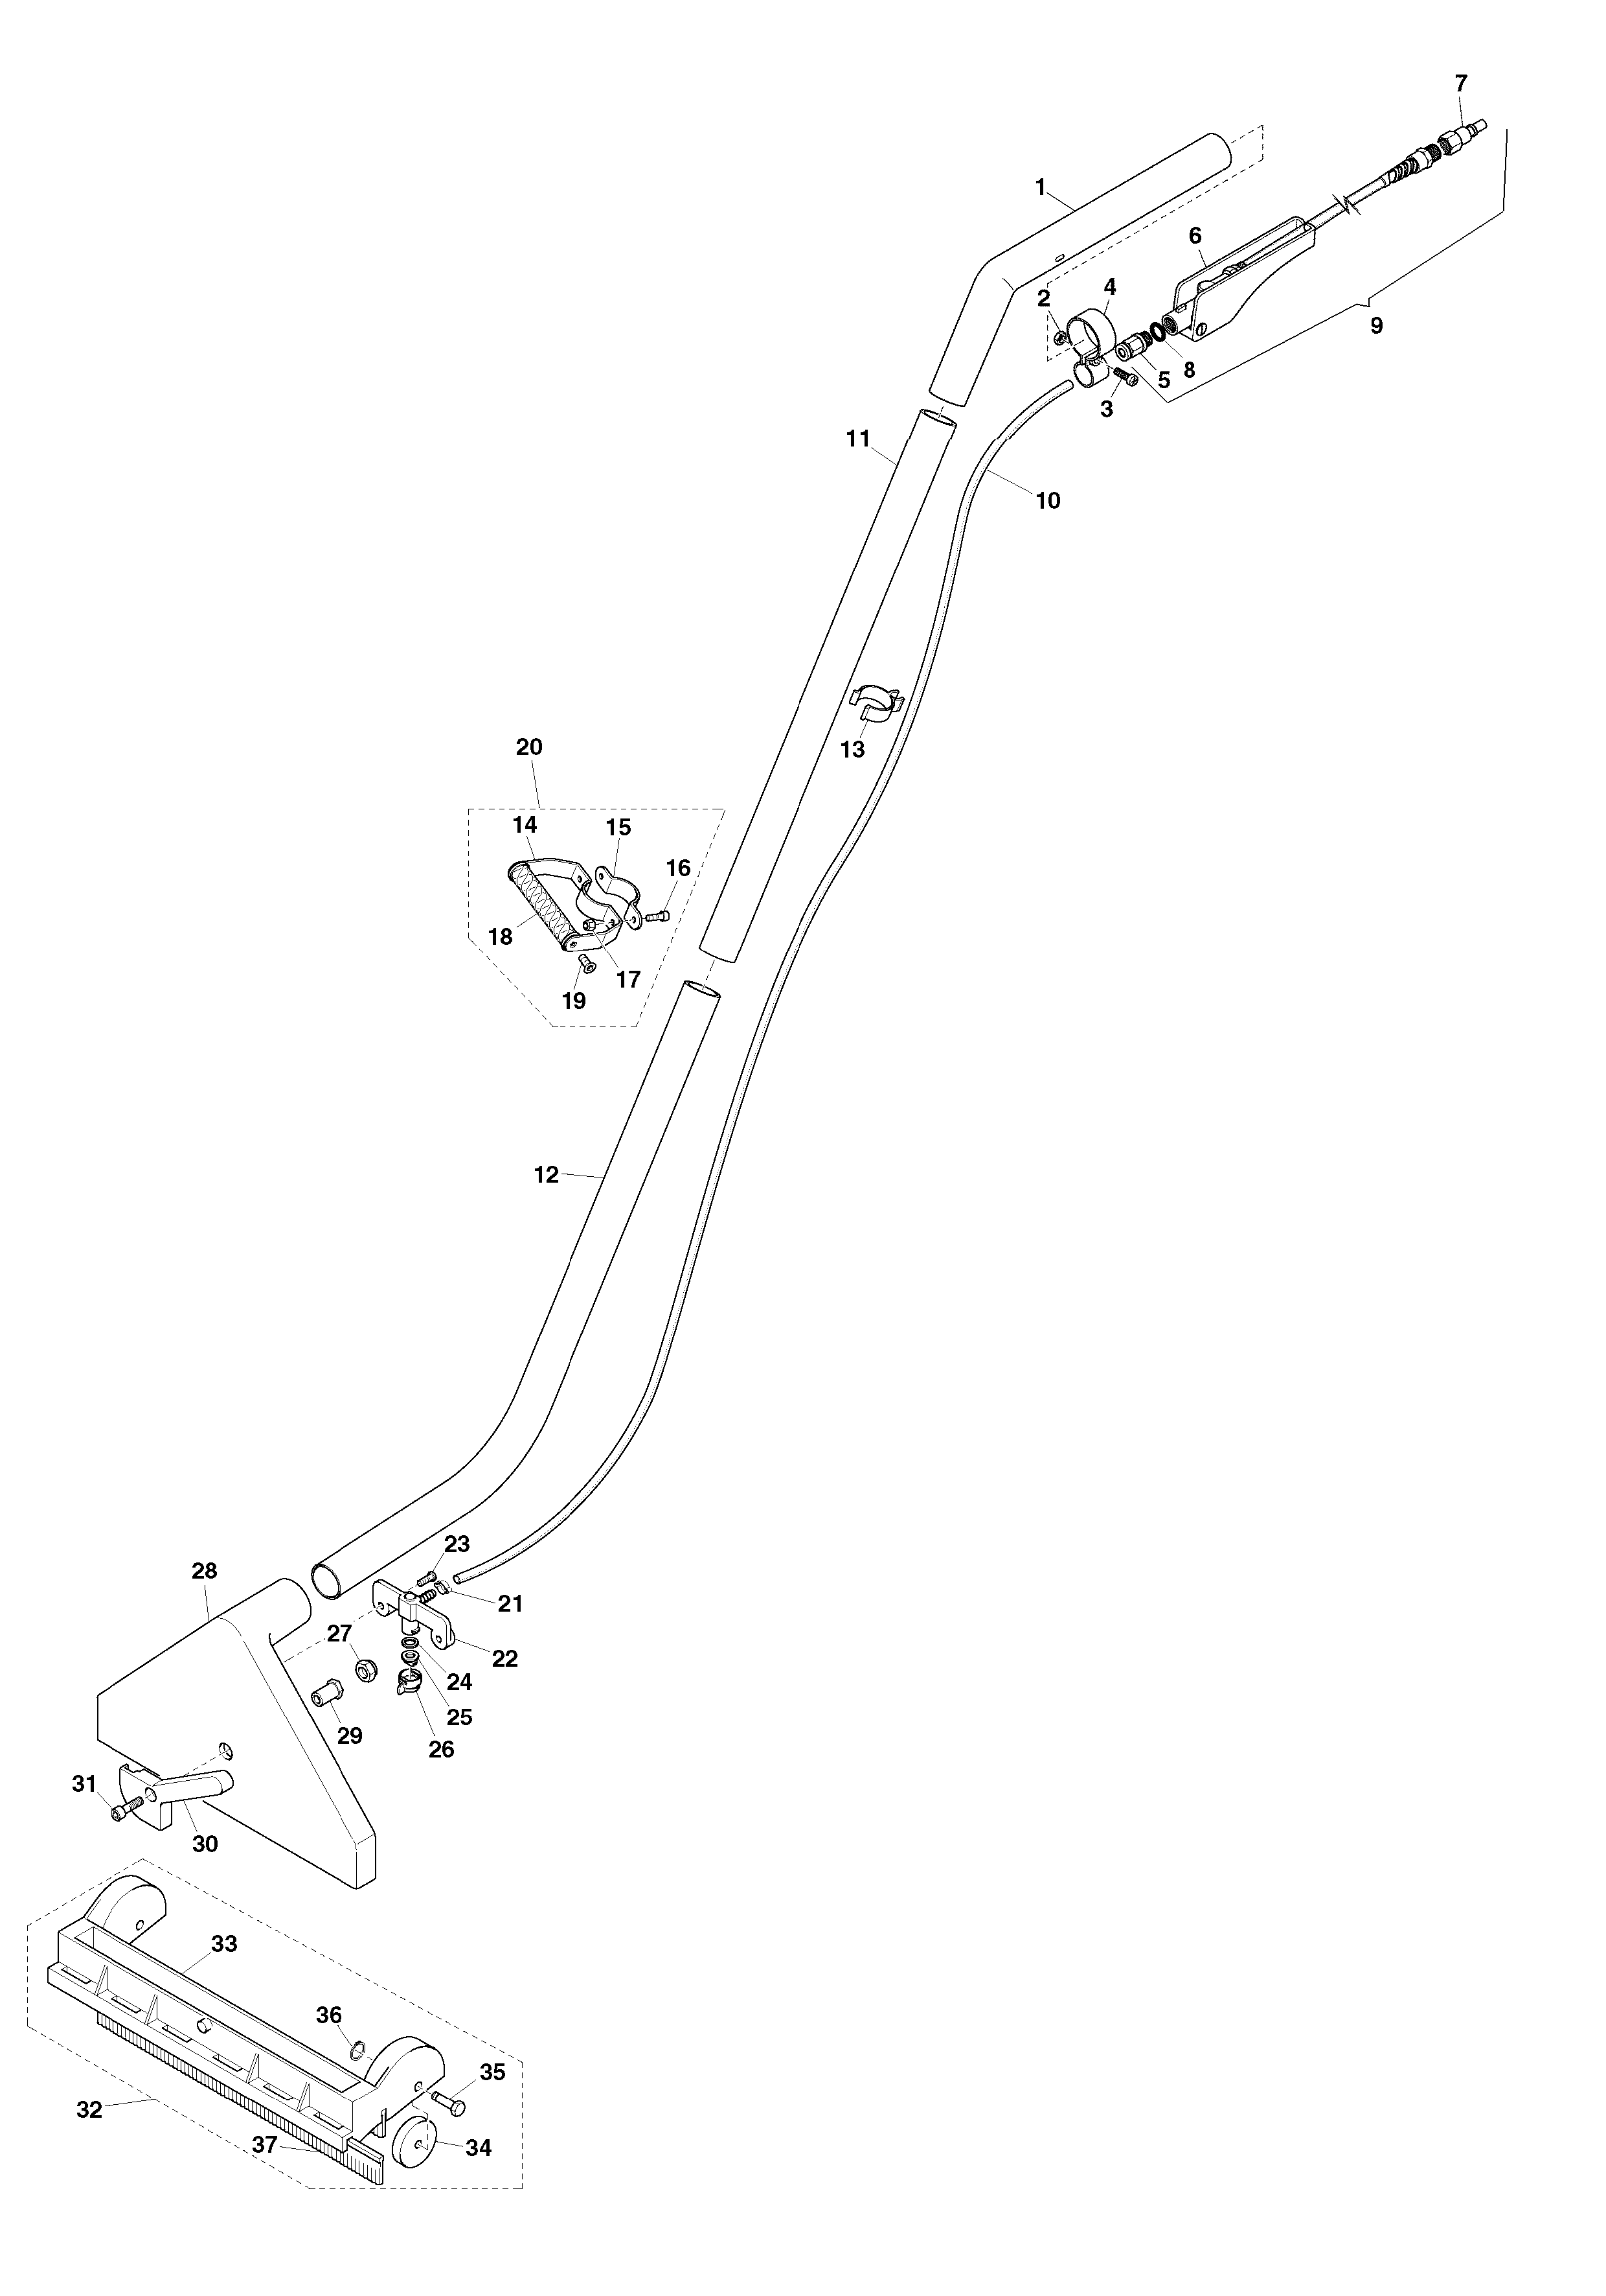
ACCESSORIO PER MOQUETTE E PAVIMENTO – NS270N-M TAVOLA 21
ACCESSORY FOR CARPET AND HARD FLOOR – NS270N-M TABLE 21
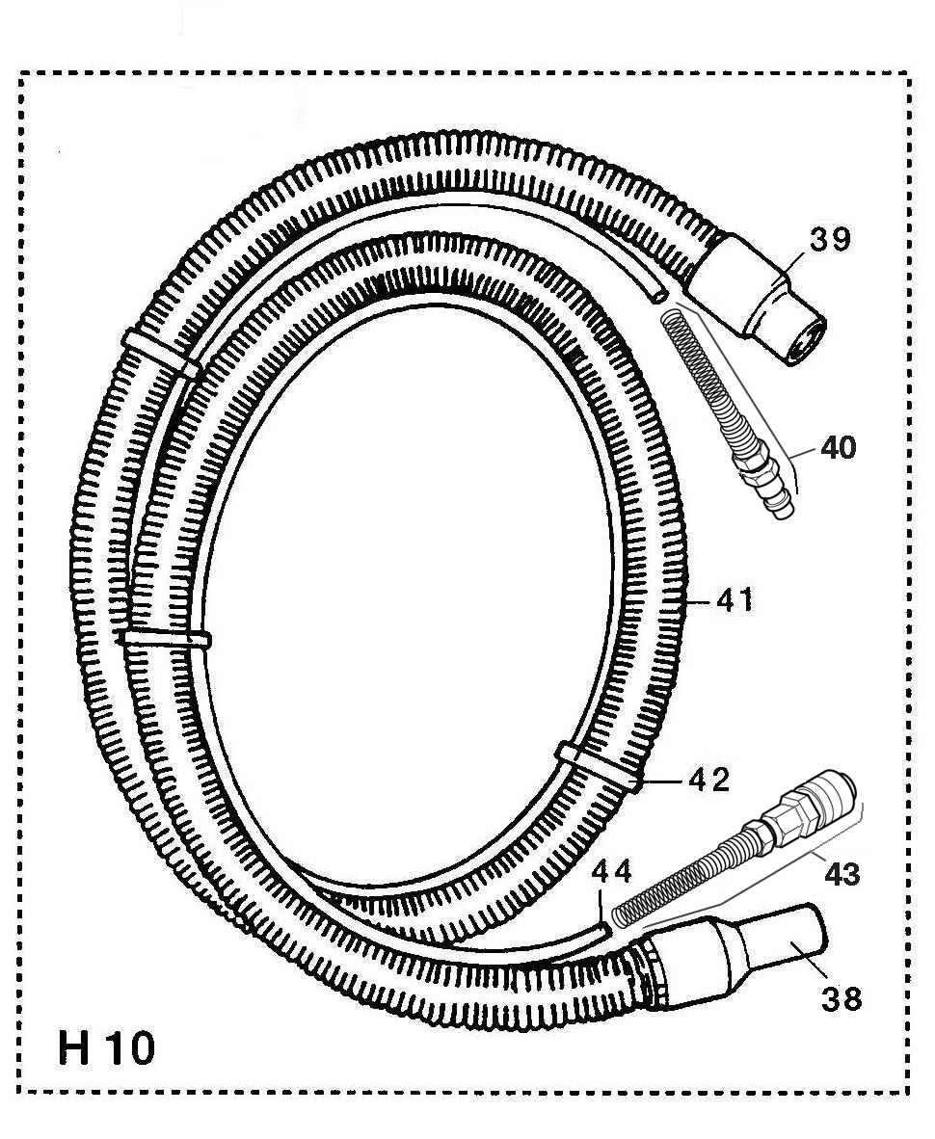
H10-M
NS270N-M
January 2008
January 2008
ACCESSORIO PER MOQUETTE E PAVIMENTI – NS270N-M |  |  |  |  |  | TAVOLA 21
ACCESSORY FOR CARPET AND HARD FLOOR – NS270N-M |  |  |  |  |  | TABLE 21
rif | codice |  | descrizione |  | description
1 |  | 306 |  | TUBO CURVO IN PLASTICA | HANDLE PLASTIC TUBE
2 |  | 525 |  | DADO D.5 | NUT D.5
3 |  | 504 |  | VITE TC+ 5x20 | SCREW TC+ 5x20
4 |  | 319 |  | FASCETTA | VALVE LOCK
5 |  | 750 |  | INNESTO AUTOM. D.8 - M.1/4 | AUTOMATIC COUPLING D.8 – M.1/4
6 |  | 3200-INN |  | RUBINETTO COMPLETO, SENZA INNESTI | COMPLETE SOLUTION VALVE, WITHOUT COUPLINGS
7 |  | 689-PE |  | INNESTO RAPIDO M. ATT. F.1/4” – METALLO | QUICK DISCONN. MALE – ATT. - F. ¼ - METAL
8 |  | 137 |  | OR 1/4" | O-RING 1/4"
9 |  | 3200C-M |  | RUBINETTO COMPLETO, INNESTO METALLO | COMPLETE SOLUTION VALVE, METAL COUPLING
10 |  | 6151 |  | SPEZZONE TUBO EXTRAFLEX | EXTRAFLEX PIPE
11 |  | 350 |  | TUBO INOX DIRITTO D.36 | STRAIGHT INOX TUBE D.36
12 |  | 305 |  | TUBO INOX CURVO D.36 | CURVED INOX TUBE D.36
13 |  | 318 |  | CLIP | CLIP
14 |  | 117.1 |  | PARTE SUPERIORE MANIGLIA | UPPER PART FOR HANDLE
15 |  | 117.36 |  | PARTE INFERIORE MANIGLIA | LOWER PART FOR HANDLE
16 |  | 574 |  | VITE 6x14 | SCREW – 6x14
17 |  | 562A |  | DADO AUTOBLOCCANTE D.6 | LOCKING NUT – DIAM. 6
18 |  | 117.3 |  | TONDO SUPPORTO PER MANIGLIA | CILINDRIC SUPPORT FOR HANDLE
 |  | 117.4 |  | MANICOTTO IN GOMMA | HANDLE GRIP
19 |  | 509 |  | VITE 6x20 | SCREW – 6x20
20 |  | 117C36 |  | MANIGLIA COMPLETA(PARTICOLARI DA 14 A 19) | COMPLETE HANDLE (ITEMS FROM 14 TO 19)
21 |  | 543 |  | FASCETTA | LOCK BAND
22 |  | 7231 |  | SUPPORTO UGELLO PER NS270N | NOZZLE SUPPORT
23 |  | 551 |  | VITE TC+ 4x16 INOX | SCREW TC+ 4x16 INOX
24 |  | 3209 |  | OR 7,66 x 1,78 | O-RING 7,66 x 1,78
25 |  | 705-02 |  | UGELLO 02/110 | NOZZLE 02/110
26 |  | 7180 |  | GHIERA PER UGELLO | RING NUT FOR NOZZLE
27 |  | 568A |  | DADO D.8 AUTOFRENANTE | LOCKING NUT D.8
28 |  | 3081 |  | BOCCA ASPIRAZIONE IN ALLUMINIO | ALUMINUM VACUUM HEAD
29 |  | 3082 |  | BUSSOLA | BUSH
30 |  | 3083 |  | LEVA | LEVER
31 |  | 5092 |  | VITE DIAM.8 | SCREW – DIAM. 8
32 |  | 3084C |  | SLITTA COMPLETA (PARTICOLARI DA 33 A 37) | COMPLETE SLIDE (ITEMS FROM 33 TO 37)
33 |  | 3084 |  | CORPO PER SLITTA | SLIDE BODY
34 |  | 3086 |  | RUOTA PER SLITTA | SLIDE WHEEL
35 |  | 3085 |  | PERNO | STUD
36 |  | 57808 |  | SEEGER | SEEGER
37 |  | 3221 |  | LISTA GOMMA | RUBBER STRIP
38 |  | 333-S |  | MANICOTTO GIREVOLE | REVOLVING CUFF
39 |  | 332 |  | MANICOTTO | CUFF
40 |  | 709-PE |  | INNESTO RAPIDO MASCHIO, CON MOLLA | QUICK DISCONNECT MALE, WITH SPRING
41 |  | 345C |  | TUBO ASPIRAZIONE CON MANICOTTI 332+333-S | VACUUM HOSE WITH CUFFS 332+333-S
42 |  | 318 |  | CLIP D.32-8 | CLIP D.32-8
43 |  | 708-PE |  | INNESTO RAPIDO FEMM.,CON MOLLA | QUICK DISCONNECT FEMALE, WITH SPRING
44 |  | 710 |  | TUBO EXTRAFLEX | EXTRAFLEX HOSE
 |  | 715-M |  | TUBO EXTRAFLEX+INN. METALLO (40+43+44) | EXTRAFLEX PIPE+METAL COUPLINGS (40+43+44)

