MILWAUKEE M18FPD3-502X 18V COMBI DRILL MIL4933479861

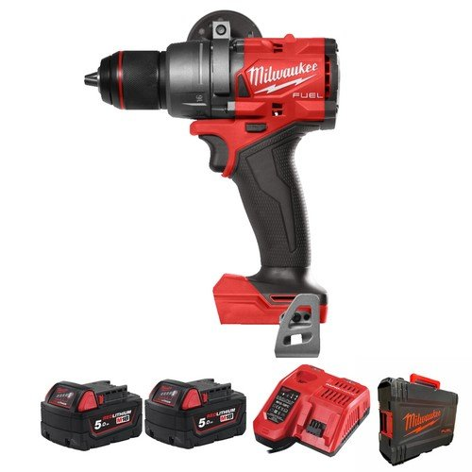

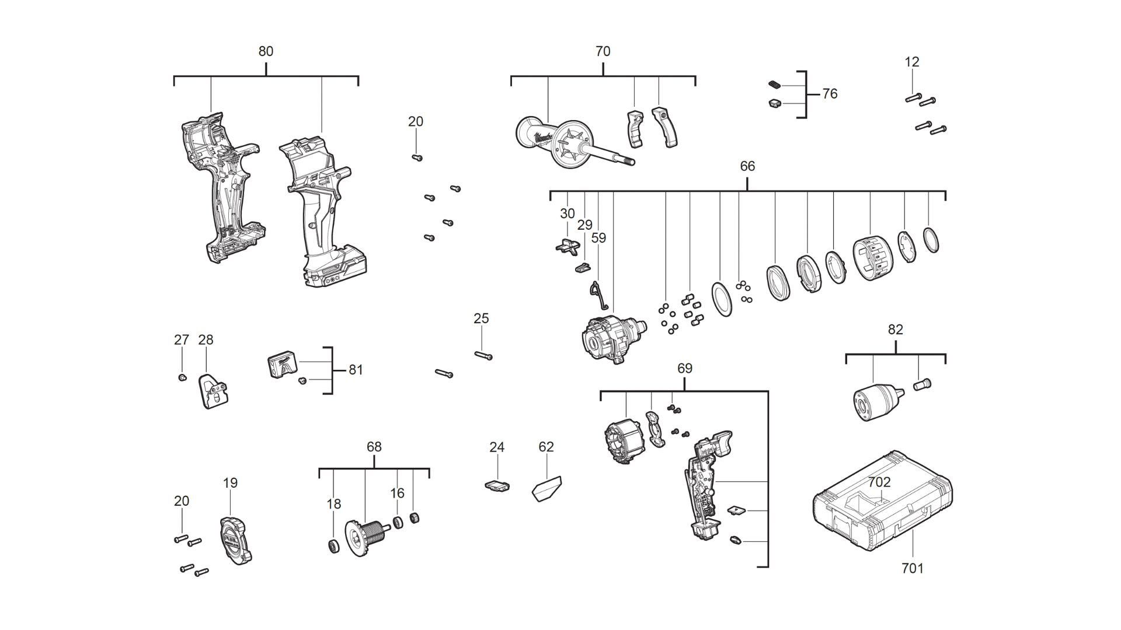

|  |  |  |  |
| --- | --- | --- | --- |
| **Position** | **Quantity** | **Description** | **Part Number** |
| 12 | 4 | SCREW | 4931465984 |
| 16 | 1 | BALL BEARING | 4931479944 |
| 18 | 1 | BALL BEARING | 4931465987 |
| 19 | 1 | PROTECTIVE CAP | 4931494902 |
| 20 | 9 | SCREW | 4931465499 |
| 24 | 1 | SWITCH LEVER | 4931494903 |
| 25 | 2 | SCREW | 4931454852 |
| 27 | 1 | SCREW | 4931465986 |
| 28 | 1 | HOOK | 4931436134 |
| 29 | 1 | SPRING | 4931494904 |
| 30 | 1 | SWITCH BUTTON | 4931494905 |
| 59 | 1 | SPRING | 4931494906 |
| 62 | 1 | RATING PLATE | 4931494917 |
| 66 | 1 | GEAR BOX | 4931494918 |
| 68 | 1 | ARMATURE | 4931494909 |
| 69 | 1 | ELECTRONIC | 4931494910 |
| 70 | 1 | HANDLE SET | 4931494911 |
| 76 | 1 | LENS | 4931494912 |
| 80 | 1 | HOUSING SET ASSY | 4931494913 |
| 81 | 1 | HOLDER | 4931494914 |
| 82 | 1 | CHUCK | 4931494919 |
| 701 | 1 | HD Box 1 - 1pc | 4932453385 |
| 702 | 4 | INSERT | 4931494916 |