MILWAUKEE M18FSZ-501X SAWZALL Kit

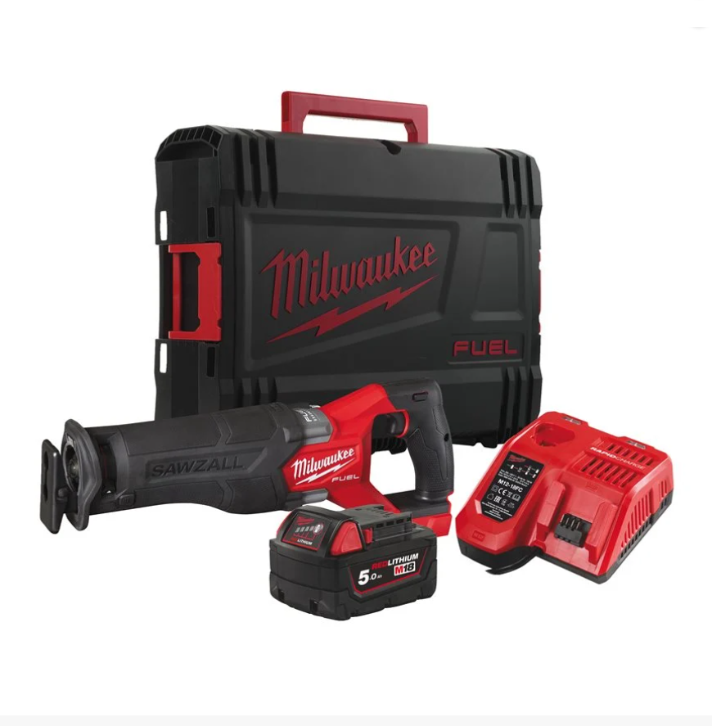

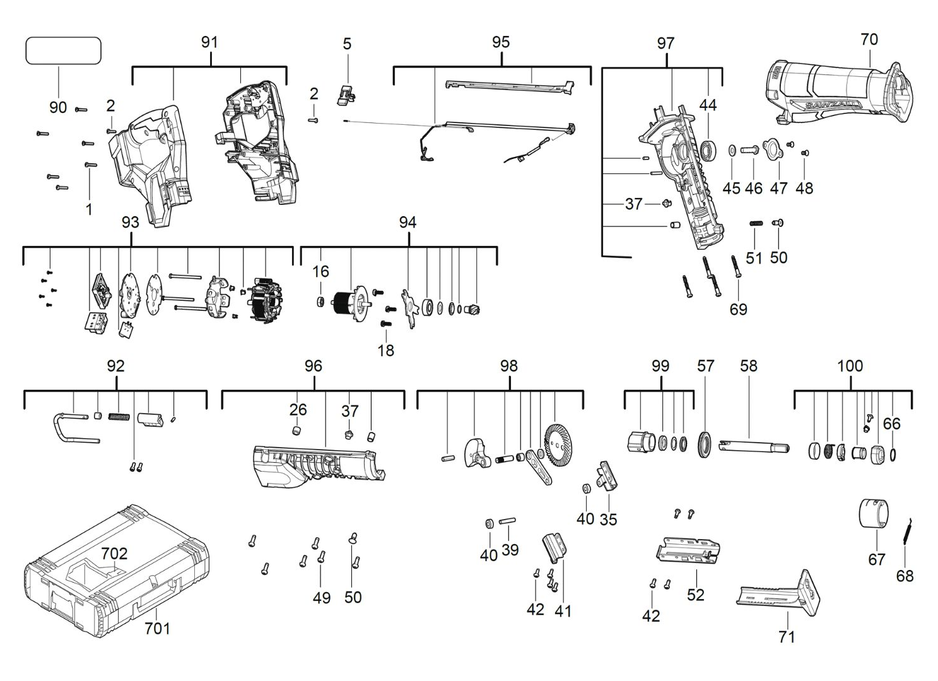

Position | Quantity | Description | Part Number
1 | 6 | SCREW | 6827261
2 | 2 | SCREW | 4931454146
5 | 1 | SLIDER | 4931473770
16 | 1 | BEARING | 4931473771
18 | 3 | SCREW | 4931436635
26 | 1 | BUSHING | 4931473772
35 | 1 | SUPPORT BRACKET | 4931473773
37 | 2 | PIN | 4931473774
39 | 1 | PIN | 4931473775
40 | 2 | SPACER | 4931473776
41 | 1 | COVER | 4931473777
42 | 8 | SCREW | 661113007
44 | 1 | BALL BEARING | 4931473778
45 | 1 | WASHER | 4931473779
46 | 1 | SCREW | 4931473780
47 | 1 | PLATE | 4931436036
48 | 2 | SCREW | 4931473781
49 | 6 | SCREW | 4931435228
50 | 2 | BUTTON | 4931473782
51 | 1 | SPRING | 4931473783
52 | 1 | BRACKET | 4931473784
57 | 1 | SEAL | 4931473786
58 | 1 | SPINDLE | 4931494973
66 | 1 | RETAINING RING | 4931473788
67 | 1 | CAM | 4931473789
68 | 1 | SPRING | 4931436050
69 | 4 | SCREW | 4931454053
70 | 1 | RUBBER SLEEVE | 4931473790
71 | 1 | SHOE RELLEVER KIT | 4931473791
90 | 1 | RATING PLATE | 4931495547
91 | 1 | HOUSING | 4931473793
92 | 1 | HOOK | 4931473794
93 | 1 | ELECTRONIC | 4931495548
94 | 1 | ROTOR | 4931495549
95 | 1 | LED LIGHT | 4931473797
96 | 1 | GEAR CASE | 4931473798
97 | 1 | GEAR CASE | 4931473799
98 | 1 | CRANK ASSEMBLY | 4931473800
99 | 1 | BUSHING | 4931473801
100 | 1 | ACCEPTANCE | 4931473802
701 | 1 | HD BOX 1 – 1 PC | 4932453385
702 | 1 | INSERT | 4931473803

