MILWAUKEE M18 COMPACT TRANSFER PUMP M18BTP-0
MIL4933471494

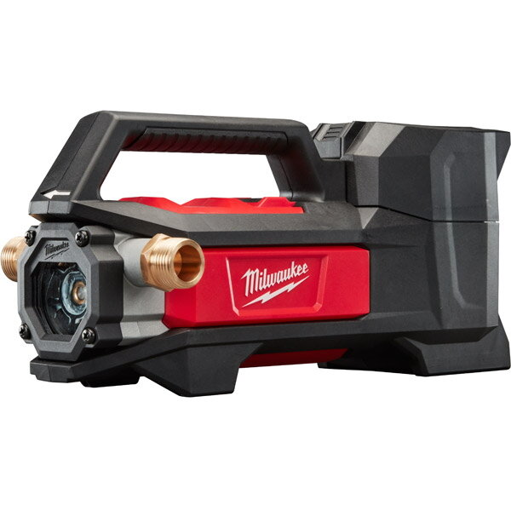

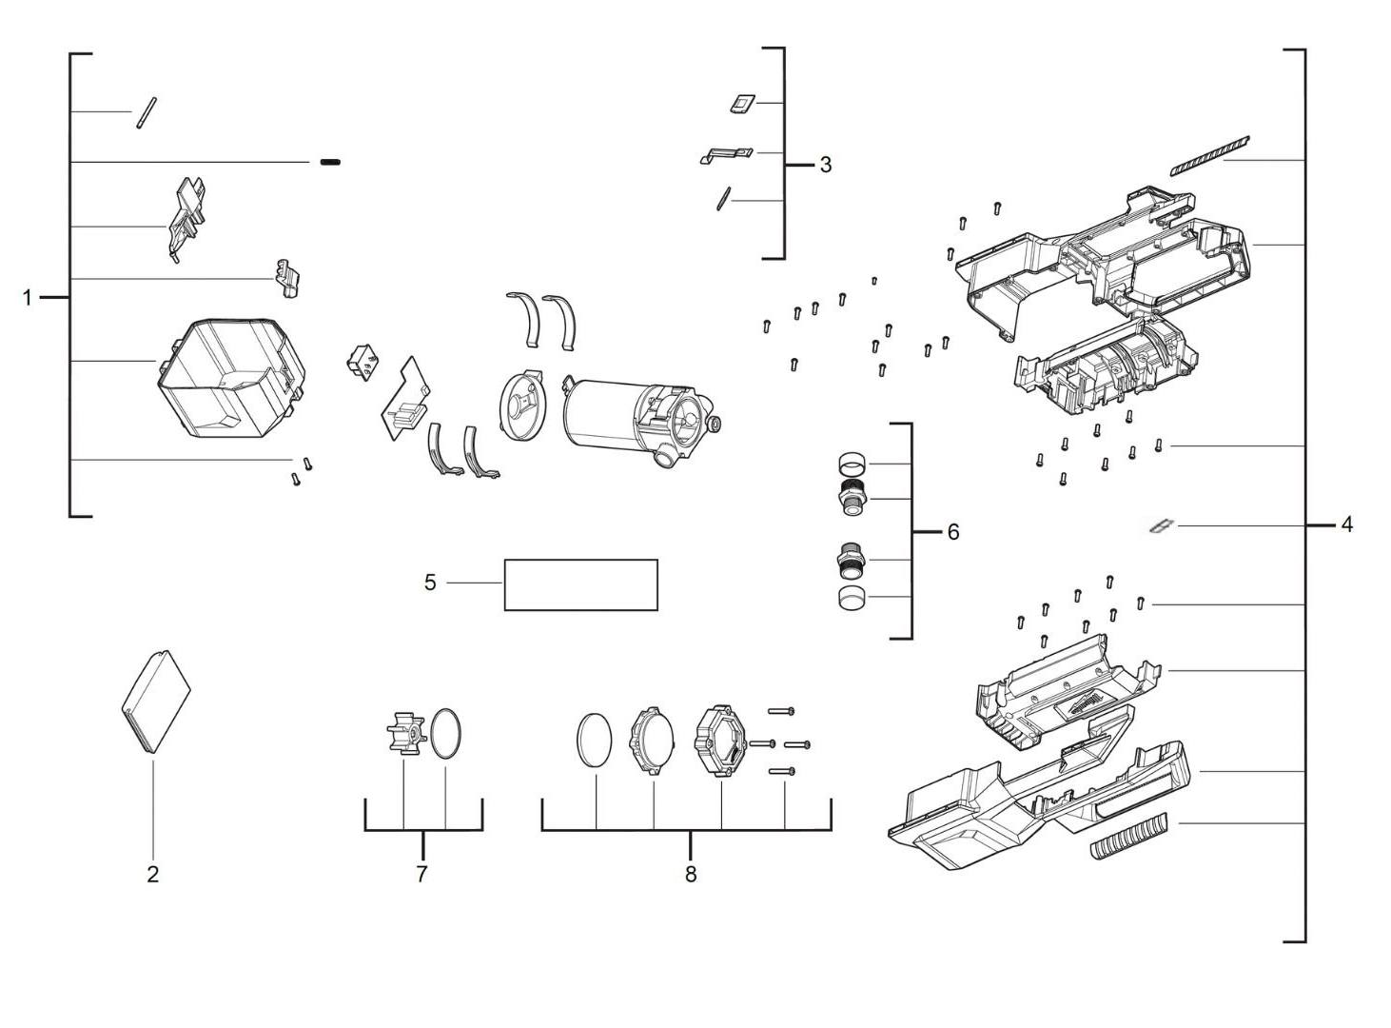

Position | Quantity | Description | Part Number
1 | 1 | DOOR | 4931472374
2 | 1 | RUBBER STOP | 4931472375
3 | 1 | SWITCH LEVER | 4931472376
4 | 1 | HOUSING | 4931472377
5 | 1 | RATING PLATE | 4931472378
6 | 1 | FITTING | 4931472379
7 | 1 | WHEEL | 4931472380
8 | 1 | LENS | 4931472381

