M12 BPRT-0 SUB COMPACT RIVET TOOL MIL4933464404

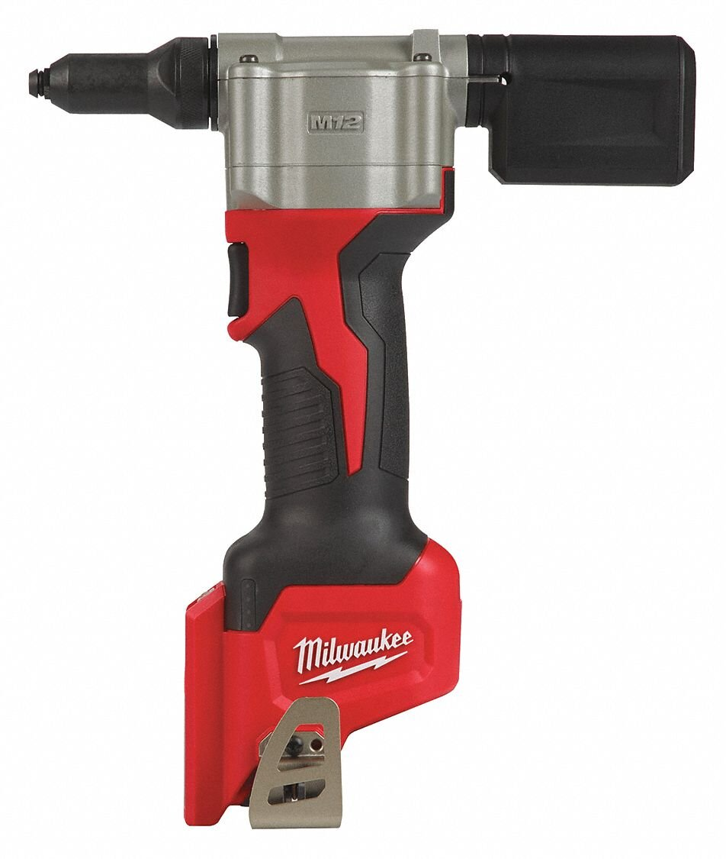

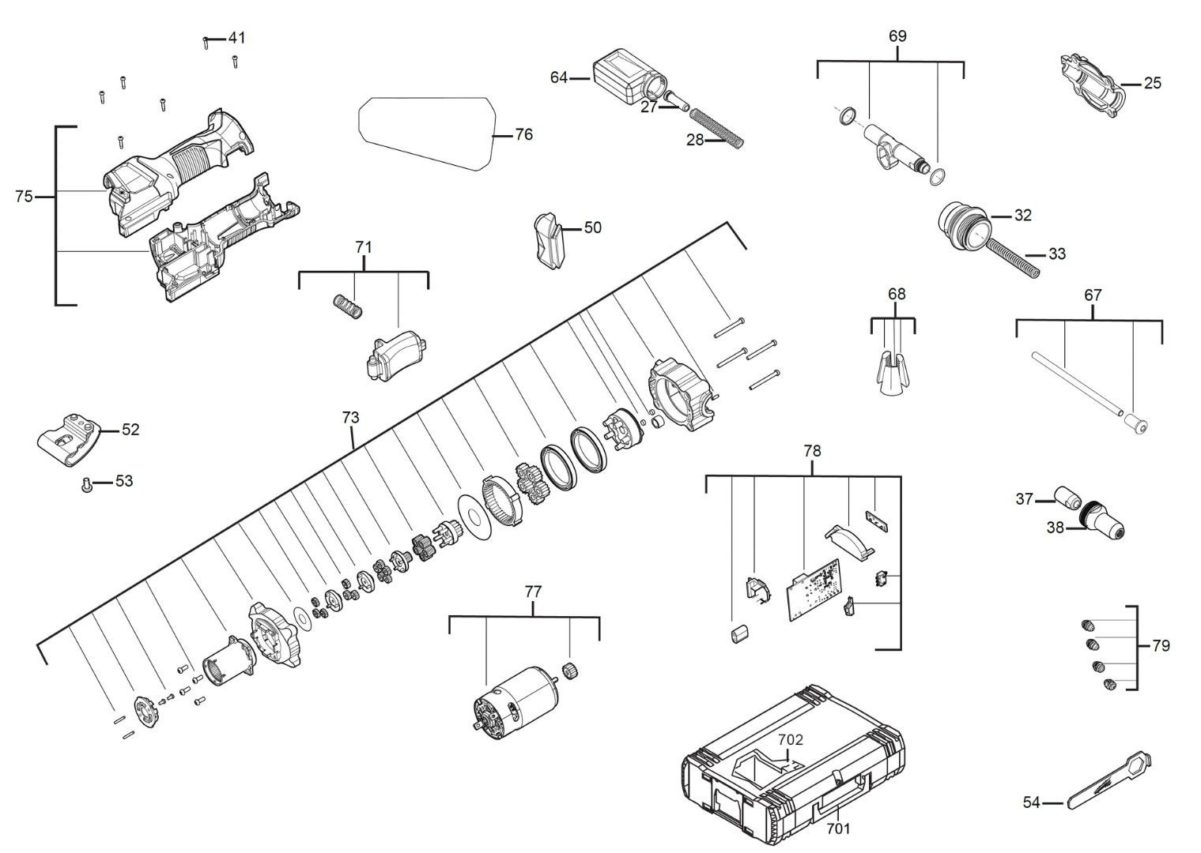

Position | Quantity | Description | Part Number
25 | 4 | HOUSING | 4931465700
27 | 2 | SLEEVE | 4931465701
28 | 2 | SPRING | 4931465702
32 | 2 | CLAMP | 4931465703
33 | 7 | SCREW | 4931465704
37 | 2 | HOLDER | 4931465705
38 | 1 | WRENCH | 4931465706
41 | 1 | SWITCH BAR | 660570005
50 | 1 | PAIR OF JAWS | 4931465707
52 | 1 | TRIGGER | 4931453220
53 | 1 | GEAR KIT | 4931436566
54 | 1 | RATING PLATE | 4931465708
64 | 1 | MOTOR ASSEMBLY | 4931465709
67 | 1 | ELECTRONIC | 4931465710
68 | 1 | 4PCS RIV.TOOL NOSE SET (RETAINING) | 4931465711
69 | 1 | INSERT | 4931465712
71 | 4 | HOUSING | 4931465713
73 | 2 | SLEEVE | 4931465714
75 | 2 | SPRING | 4931465715
76 | 2 | CLAMP | 4931465716
77 | 7 | SCREW | 4931465717
78 | 2 | HOLDER | 4931465718
79 | 1 | WRENCH | 48540100
702 | 1 | SWITCH BAR | 4931465719

