MILWAUKEE M18 BMT-0 MULTI-TOOL (NAKED) MIL4933446203

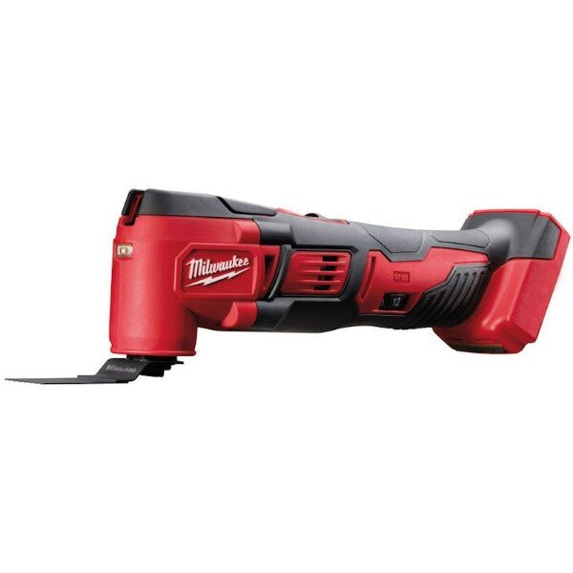

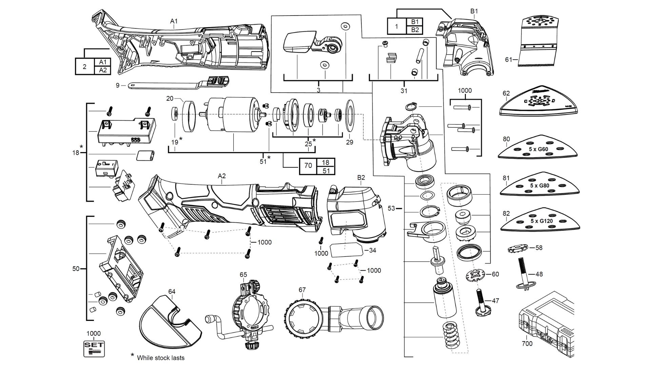

|  |  |  |  |
| --- | --- | --- | --- |
| **Position** | **Quantity** | **Description** | **Part Number** |
| 1 | 1 | HOUSING CAP | 4931436180 |
| 2 | 1 | HOUSING | 4931436181 |
| 3 | 1 | RELEASE LEVER | Item discontinued  -4931436182 |
| 9 | 1 | SWITCH LEVER | 4931436183 |
| 18 | 1 | SWITCH | Item discontinued  -4931436184 |
| 19 | 1 | MAGNETIC DISC | Item discontinued  -4931436185 |
| 20 | 1 | RUBBER RING | 4931436186 |
| 25 | 1 | BEARING KIT | Item discontinued  -4931436187 |
| 29 | 1 | WASHER | 4931436188 |
| 31 | 1 | CLAMPING SET | 4931436189 |
| 34 | 1 | RATING PLATE | Item discontinued  -4931436190 |
| 47 | 1 | CLAMPING SCREW | 4931436191 |
| 48 | 1 | STRAINING SCREW | 4931447570 |
| 50 | 1 | TERMINAL STRIP | 4931436192 |
| 51 | 1 | MOTOR ASSEMBLY | Item discontinued  -4931436193 |
| 53 | 1 | GEAR BOX KIT | 4931436194 |
| 58 | 1 | CLAMPING FLANGE, Adapter | 4931447571 |
| 60 | 1 | ADAPTER | 4931447572 |
| 61 | 1 | SAW BLADE | 4931473395 |
| 62 | 1 | GRINDING DISK | 4931447574 |
| 64 | 1 | KNIFE PROTECTION | 4931447578 |
| 65 | 1 | DEPTH GAUGE | 4931447579 |
| 67 | 1 | DUST EXTRACTION AS. | 4931447580 |
| 70 | 1 | MOTOR ASSEMBLY | 4931452215 |
| 80 | 1 | SANDING PAPER | 4931447575 |
| 81 | 1 | SANDING PAPER | 4931447576 |
| 82 | 1 | SANDING PAPER | 4931447577 |
| 700 | 1 | CARRYING CASE | 4931447720 |
| 1000 | 1 | SCREW | 4931436195 |